**I. Power BI Installation**

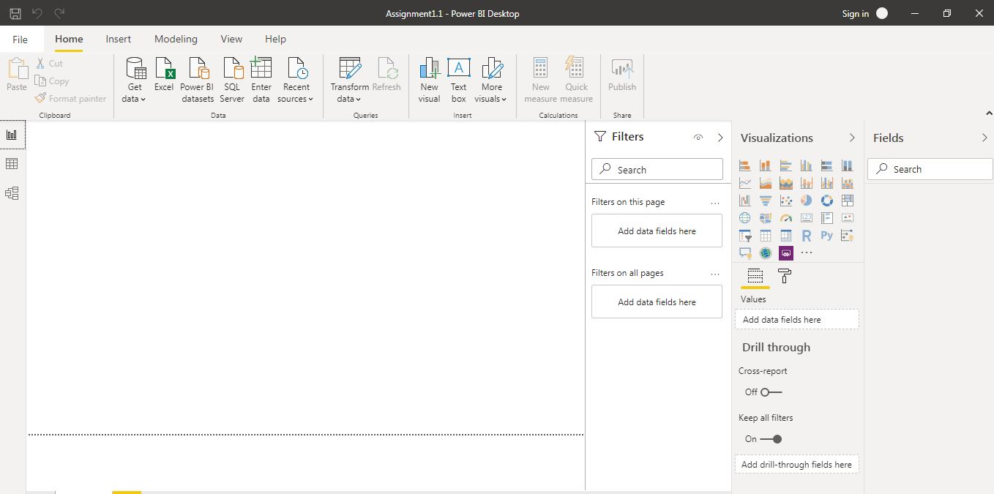

**Report view**

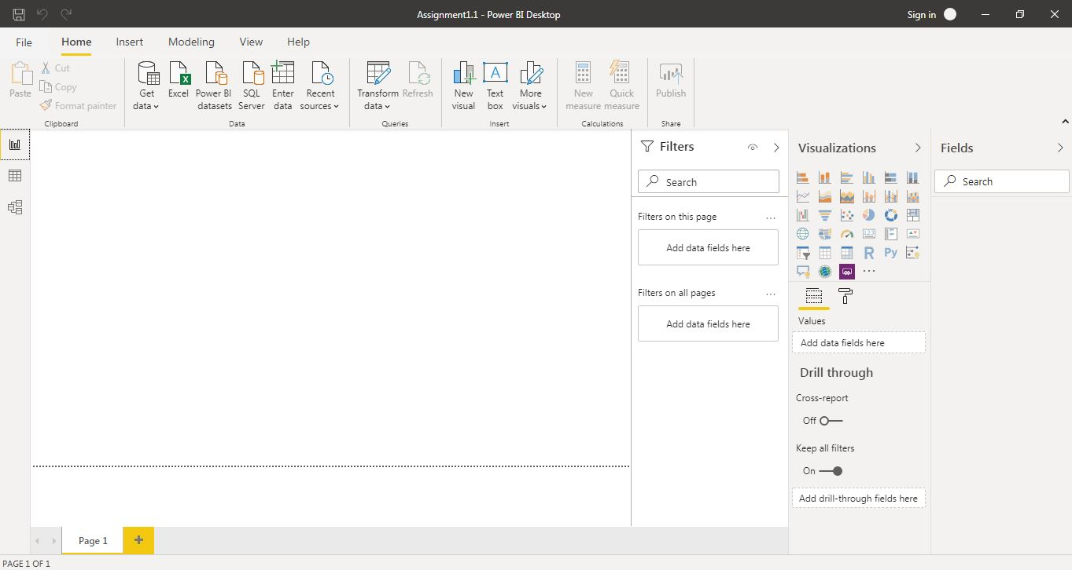

**Data View**

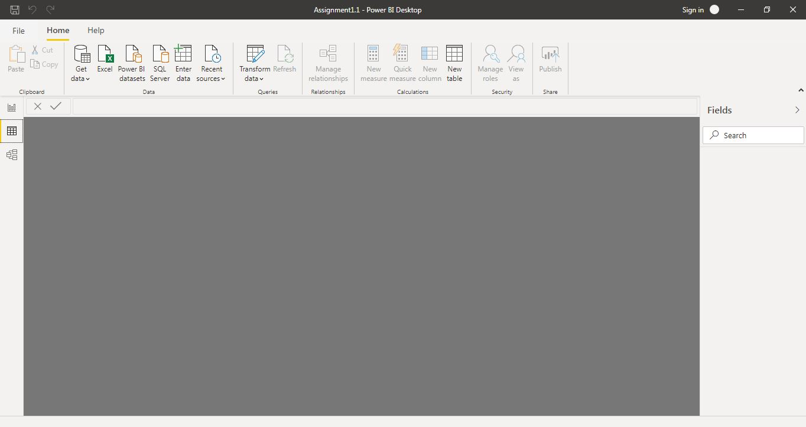

**Model view**

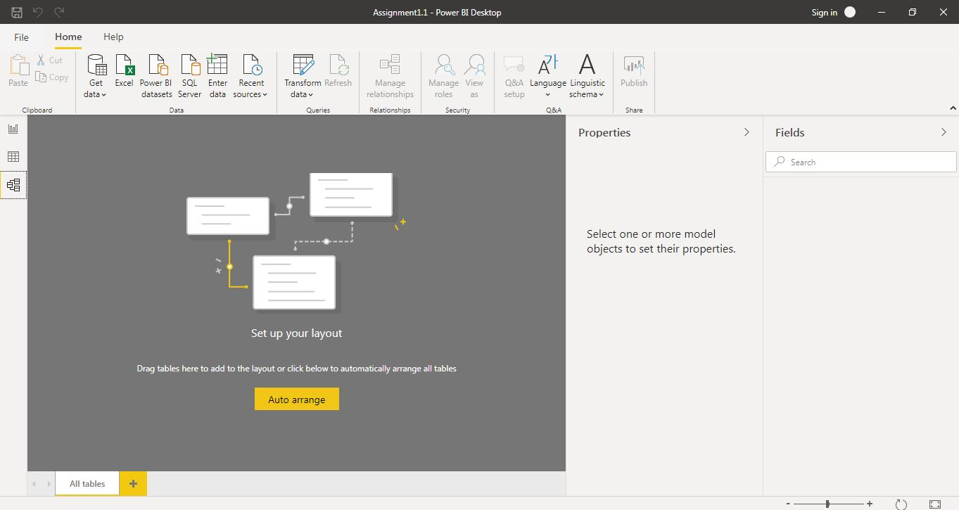

**Power Query Editor**

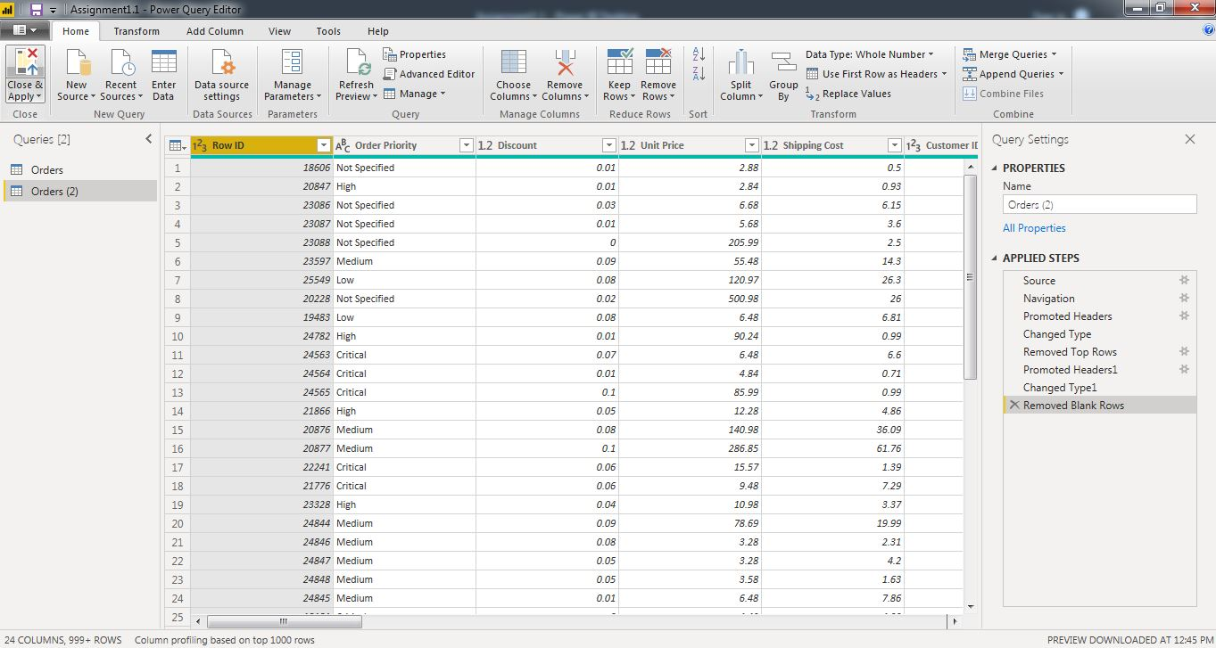

**Advanced Editor**

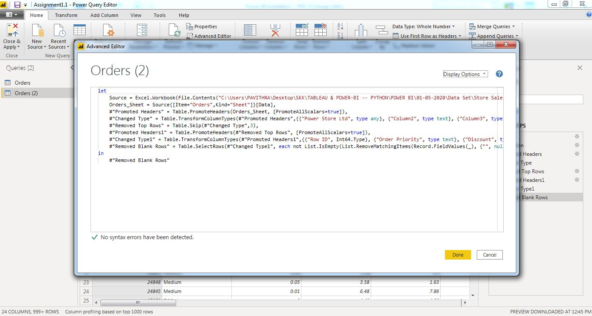

|  |  |
| --- | --- |
| **Software Type** | **Price** |
| **Power BI Desktop** | **Free** |
| **Power BI Pro** | **$9.99** |
| **Power BI Premium** | **$4995** |